1. Add UISearchDisplayDelegate, UISearchBarDelegate to ViewController
2. Drag SearchBar and SearchDisplayController to XIB

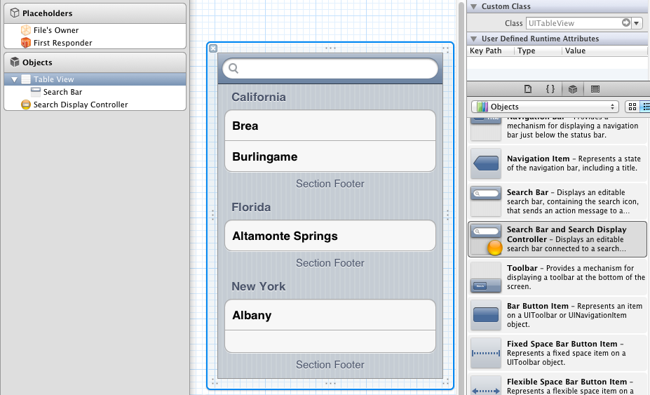

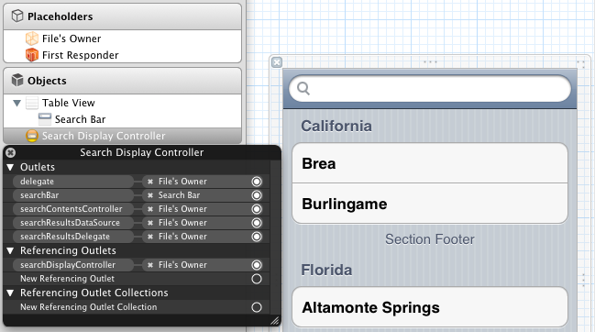

1. swds